FFGC September 2019 Board Meeting – Board Member Reports
Note: to get to a specific report:
- Find the page number in the table of contents for the report you wish to locate.
- Go to lower left corner and click on Page: 1 of 31.
- In the Go To dialog box that appears enter the page number you wish to go to and then click on GoTo.
Table of Contents
100th Anniversary 2
Advocacy Workshop 3
Affiliates Membership Report 4
Amazon Project 5
Bee Report 6
Bricks Report 7
Blue Star Memorial Marker Report 8
BOI Report 10
Convention Coordinator 2019 Report 11
Convention 2019 Summary Report 12
Convention 2020 Report 15
Deep South Unified Project 16
Deep South Unified Project Award Rules 17
Deep South Convention 2020 Report 19
Earth Steward Recognition Report 20
Environmental Consultants Council 21
FFGC Calendar Finance Report 22
FFGC Calendar Report 23
FFGC Scholarship and Endowment Report 24
FFGC, NGC, DS Life Memberships Report 26
Finance Committee Report 27
Florida Flower Show Judges Report 28
Gardening Consultant’s Council Report 29
Girl Scout Liaison Report 30
Grants Report 31

100th Anniversary

100th Anniversary Report
Tina V. Tuttle
11 September 2019

2024 will be here before we know it! Therefore, it is imperative that as much preplanning as possible be accomplished.

To date, the fundraising campaign as announced at convention 2019 and as published in The Florida Gardener, has raised $15,250. That means that 12 individuals, 1 district, 1 judges council, and 1 club have each given $1000 and one club has taken the option of pledging $250 annually for four years. A large candle has been made to measure our success.

“The First Fifty Years: Florida Federation of Garden Clubs, Inc. 1925-1975” is being retyped so it can become the new history book for the Federation. Former Historian, Margaret Chodosh, has been helpful in providing the history for the last 4 presidencies. It is hoped that this complete history book will also include a history of Wekiva Youth Camp, which turns 50 in 2024, a history of the Blue Star Markers in Florida and as history of SEEK.

The venue for the 2024 anniversary convention has been selected and contracts are being negotiated with Hyatt, Jacksonville. A state flower show will be held in 2024 but not at the hotel; The Garden Club of Jacksonville has been requested to host not only our state flower show that year but also to host a reception in the middle of the show for the Board of Directors and early arrivals.

Art departments at University of Central Florida and Rollins College have been contacted for ideas on a commissioned sculpture for the headquarters grounds.

Tina V. Tuttle, 2VP
100th Anniversary Chairman

Advocacy Workshop

ADVOCACY WORKSHOP
January 22, 2020, dinner
Mounts Botanical Garden, West Palm Beach, FL
The Advocacy Workshop for approximately 50 attendees would be led by a panel comprised of Sierra Club members Drew Martin, Jim Ewing and Martin Landau as well as Mary Mertz with the League of Women Voters. State and US legislators would also be invited.
The panel would focus on environmental legislation pending in January 2020 and effective ways of advocating to our legislators. This could also include matters being considered by county and city councils.
Attendees would each be given a folder comprised of the following:
- • Cover page detailing information on sponsors and panel members
- • Current legislation outlines
- • US and State Legislator contact information
- • Copies of the following guidelines found on the National Garden Club website http://gardenclub.org/forms/Default.aspx
- 1. #1293 Advocacy Glossary, 3 pages
- 2. #1294 Congressional Staff Roles, 1 page
- 3. #1295 Understanding How A Bill Becomes Law, 2 pages
- 4. # 1296 How to Schedule Meetings with Congress, 2 pages
- 5. # 1297 Surviving “Thomas” Using the Library of Congress website described below, 2 pages
- 6. #1298 How to Write a Letter to Congress, 1 page

HOW TO SERIES: SURVIVING “THOMAS” – THE LIBRARY OF CONGRESS FEDERAL LEGISLATIVE INFORMATION CENTER
THOMAS was launched in January of 1995, at the inception of the 104th Congress. The leadership of the 104th Congress directed the Library of Congress to make federal legislative information freely available to the public. Since that time THOMAS has expanded the scope of its offerings to include the features and content listed below.

Affiliates Membership Report

Affiliate Membership Report
Donna Berger, Chairman
September 9-12, 2019

FFGC has an Affiliate Membership Program where like -minded organizations, such as conservation organizations, plant societies, floral design clubs, etc, may join FFGC for $50. They receive a subscription to the Florida Gardener and an invite to FFGC Convention, as well as a listing on the FFGC website and in the Florida Gardener.

We have Seven Affiliate Members and would like to increase that number. As your Membership chairman I’m sure that some affiliate members have been overlooked. Please feel free to contact me if we have missed anyone and also if you have an organization that you would like to contact to become an Affiliate member of FFGC.

In the Fall Issue of the Florida Gardener you will find an article on membership details as well as a list of the members and the clubs they are affiliated with.

We are pleased to welcome the following who joined in 2018-2019.

Mounts Botanical Garden – West Palm Beach GC
Heathcote Botanical Garden – GC of Fort Pierce
Patricia Davis Community Garden – Pompano Beach GC

Feel free to contact me with any questions or concerns.

Let’s see if we can’t build up our Affiliate Membership this coming year!

Amazon Project
Report
Amazon Chairman Report
Linda Feifarek-Johnson Chairman
September 11, 2019
Board of Director’s Meeting

Good Morning,
I cannot tell you how many times in the past I ordered something from Amazon and have been in a hurry so I went to the APP. Well, I am going to make it so much easier, no one will have any excuse not to go through the FFGC home page.
First off, you need to make the FFGC home page an app on your phone or tablet.
To set FFGC as an app in iPhone - pull up FFGC home page. On bottom of this iPhone page find a square with and arrow pointing up. This square is at the top of the screen on an iPad. Tap this icon. A menu screen comes up and tap on a black icon square with a plus in the middle of it and labeled “add to home screen”. Rename the icon if you wish.
To set FFGC as an app on android - open your browser. Tap the browser icon on your home screen or app drawer. open the menu (press the menu button on your device or tap the menu button icon in the upper-right hand corner of the browser window). Tap settings, tap general, tap “set home page” and then tap OK to save.
Once you have set FFGC home page as an app, tap on it, scroll down to the bottom and tap Amazon. Once the Amazon home page comes up, you will have to sign in ONLY the first time you use it. After that, Amazon will remember you and you will automatically be signed in.
How easy is that! Easy, peasy. Now I want to see our sales soar!

Bee Report

Bees
Christy Linke
September 9, 2019

Bees whether Honey bees or Native bees that’s what all the buzz is about. Both are keeping this Chairperson super busy. Promoting Bees through Knowledge is what this Chairperson does. Traveling to garden clubs all over the state and educating everyone who will listen about native bees and the important role they play in pollinating. Doing programs at State Parks, such as Sunken Gardens in St. Petersburg, or Circle B Preserve in Lakeland where this Chairperson educates adults and children. Making bee houses out of cans for hanging in your yard to using Keurig cups (recycled) as seed containers. This chairperson is always buzzing anywhere to promote bees which play such an important role in our everyday life, the food we eat and the beautiful flowers we love to see and smell.
Summary:
The goal is and always will be to educate all ages on the importance of bees.

Bricks Report

Brick Path Chairman
Joanne Mulinare
August 24, 2019
Orders are slow coming in over the summer. We do anticipate placing an order after the Fall board meeting, when we reach the minimum number. In addition to a few memorial bricks on order, we are going to update the FFGC presidential path area in the front of the building with the most recent presidents.
We will display order forms at the Fall board meeting to encourage members to distribute and use them.

Summary – Brick orders are always welcome.
Joanne Mulinare

Blue Star Memorial Marker Report

Blue Star Memorial Program
Blue Star Memorial Chairman
Rosita Aristoff
September 11, 2019

- New and Pending Blue Star Memorial Marker Activity

- The New Port Richey Garden Club (District VIII) – Blue Star Memorial By-Way Marker was dedicated on May 25, 2019.

- The Palm Beach Gardens Garden Club (District X) – A new Gold Star Families Memorial Marker was dedicated on May 27, 2019.

- The Ocean Ridge Garden Club (District X) – A new Blue Star Memorial Marker was dedicated on May 27, 2019.

- The Tampa Federation of Garden Club Circles (District VIII) - A new Blue Star Memorial Marker was dedicated on June 15, 2019.

- The Temple Terrace Garden Club (District VIII) – The orphaned Mango GC marker adopted by and relocated by the Temple Terrace GC and will be rededicated on November 11, 2019.

- The Wauchula Garden Club (District IX) - A new Blue Star Memorial Highway Marker dedication is still planned for November 11, 2019.

- The Wellington Garden Club (District X) - A new Blue Star Memorial Marker was ordered and a dedication is planned for November 11, 2019.

- The Milton Garden Club (District I) – S.R. 87 has been designated by the Secretary of FDOT as a Blue Star Memorial Highway. A new Blue Star Memorial Highway Marker has been ordered for placement along S.R. 87 near Naval Air Station Whiting with a dedication planned in November, 2019.

- The Punta Gorda Garden Club (District IX) – Authorization was received from the NGC Blue Star Chairman for the club to place a Blue Star Memorial Marker in their city’s Veterans Park in time for a spring 2020 dedication.

- The Garden Club of Cape Coral (District IX) - Authorization was received from the NGC Blue Star Chairman for the club to place a Blue Star Memorial Marker in the Veterans Memorial section of their Eco Park.

- The Miami Beach Garden Club (District XII) – The Blue Star Memorial Highway Marker along US 1 originally dedicated in 1954 by the now disbanded Tropical GC has been adopted by the Miami Beach GC which plans to have the historical marker restored.

- Hurricane Michael Impacts Blue Star Markers in District II

- The financial assistance plan has replaced three damaged support posts.
- In mid-October Historical Markers Restorations will totally restore six Blue Star Memorial Highway Markers in District II with funds provided by the financial assistance plan. These markers are located in Chattahoochee, Cottondale, Parker, Tyndall A.F.B., Marianna and Port. St. Joe.

- Other Developments

- FDOT is beginning to enforce a new maintenance procedure introduced some time ago, but not formally advised to the FFGC. As such, FDOT now “strongly suggests” all garden clubs wishing to continue to acquire new, or maintain existing, Blue Star Memorial Highway Markers obtain a General Use Permit from their regional FDOT office (at no cost currently) and to renew this permit every five years.

- Summary
One new Blue Star Memorial Highway Marker and one new Blue Star Memorial Marker have been ordered.

The financial assistance plan designed to specifically assist a number of District II garden clubs with care of their Blue Star markers after Hurricane Michael will allow for restoration of six such markers by mid-October, 2019.
A new FDOT maintenance procedure may require garden clubs to submit permit applications for existing and/or new Blue Star Memorial Highway Markers.

Rosita A. Aristoff
Rosita A. Aristoff
Blue & Gold Star Memorial Chairman

BOI Report

Book of Information Report
BOI Chairman
Karen Smith
September 11-12, 2019

The Book of Information (BOI) can be thought of as our directory which, in conjunction with our FFGC website, makes up our yearbook ... our living history.
Our 2019-2021 edition is a bit thinner than in years past. All essentials are included and members are encouraged to become familiar with our website and how to find the information they need.
This BOI is posted (in its entirety) on our website home page, alphabetically under Blue Star Memorial Marker Locations, and will be updated before our January Board meeting and again prior to our Convention Board meeting.
The next printed version will be the 2020-2021 BOI Supplement, distributed in September 2020.
Following this meeting, and after you and your club/circle presidents have a chance to review the entire BOI, submit any changes, in writing ... via email to this chairman, not to our Office Manager Liea. Such changes might include: new or deleted club, contact information for club/circle president (i.e. change of address, email, or phone).
Listing of FFGC Chairmen and FFGC Chairmanships can be found on ffgc.org ...
From the green "HOME" tab, see the dropdown list, click "About FFGC"
All chairmen with changes to their email, address, phone, etc. are asked to send these changes, via email to this Chairman, not to our Office Manager Liea Ward. Please note in subject line: BOI change.
SUMMARY:
We hope you enjoy this edition of the Book of Information. With your help, the BOI can be maintained as a living document.

Convention Coordinator 2019 Report
REPORT
FFGC Convention Coordinator
Cissy Richardson
September 11, 2019
This Chairman is pleased to report that the 2019 Convention held at the World Golf Village was a success.
Kudos to President Bates, Helen Purvis and Jana Walling for a job well done.

The 2020 Convention planning is well underway with all the committee chairs in place and working. A
meeting will be held on Tuesday, Sept 10 and Wednesday, 11th to review details and plans. This convention
will be held at the Tampa Downtown Hilton.

The 2021 Convention planning is also getting underway. This convention will be held at the Hilton in Daytona.
Initial planning has begun and a meeting will be scheduled this Fall in Daytona to get the committee underway.

Contracts have been signed at the Embassy Suites, Kissimmee, for the 2022 and 2023 FFGC Conventions.

Contract is in the process of negotiations for the 2024 FFGC Convention to be held in Jacksonville.

Cissy Richardson

Convention 2019 Summary Report
2019 Convention Report
September 11, 2019
Helen Purvis, Jana Walling, Co-Chairs

When asked to Chair the 2019 FFGC Convention by President Bates, there was some hesitation, knowing what a huge job it would be. However, it was felt that it would be good for District III to take an active role. Typically not many people from District III attend the FFGC conventions and as President Bates pointed out, there was a possibility that the 7 clubs in District III would profit not only financially, but be able to connect with garden club on a statewide level.
Having Jana as co-chair was a good decision. She is a detail person and a whiz with finance records, as evidenced by her being current FFGC Treasurer.
Finding Chairs for the various committees is always a challenge. Those who you think would be a great chair don’t necessarily follow through, but if you’re reading this report, you obviously have had plenty of experience with that.
Our best hire (?) was Sudi Scott as our graphics designer. We wanted all the print material to be consistent and attractive. Sudi owns her own graphic design firm and is great to work with and is located in Tallahassee. She has a working relationship with the printer that we chose. We started with the flyer that was passed out at the 2018 convention, inviting members to attend the 2019 convention. The contract had already been signed for two years with the hotel so we didn’t have that job of picking the venue.
Next was the Sponsorship brochure. After presenting it to the finance committee and getting their okay, we solicited sponsorships. Basically, it was just asking people that we knew owned businesses and those that have sponsored FFGC before. This has to start early, like right away, because of their fiscal year and preparing their budgets. We had a goal of $10,000. We had asked members if they knew of any good contacts to let us know and we would contact them because we didn’t want members talking to the same potential donors. We only heard from a couple of members with suggestions. It was just me and Jana soliciting. This could be a separate committee, but we chose to do it ourselves. Brochure is attached.
Next was the opportunity drawing. We chose not to do the daily raffles, baskets that had previously been done because it was so much work for the members and we felt that we could raise the same amount with the sponsorships. We chose to do a 50/50 as the top prize. The second prize was a beach rental at St. George and this was a personal contact that donated. The rest of the prizes were donated from President Bates. Tickets were designed and printed. We printed 15,000 tickets. This is an arbitrary number but we thought one for each member, with some extra. We kept 1000 tickets back so when someone would ask for additional tickets, we could send them. We encouraged members to ask in their district if anyone had extra tickets to redistribute. They were distributed at the September FFGC Board meeting. That also was a fiasco because there was not a complete listing of the clubs’ members so we guessed on how to distribute them. We did it with the help of the BOI and divided them into envelopes with club name and gave them to the district directors to pass along, thinking they would do this at their fall district meetings. Ticket is attached and you can see we tried to give instructions as to how they were to be returned but you can’t imagine how confusing that is to some members. I did not feel the tickets need to be numbered because that costs extra and there is no advantage to that. Some people thought they needed to be numbered so you could keep up with the tickets but that is totally unmanageable. The chairman, Marilyn Larson, is a very organized person and we could write a book on her experience. People would return the wrong side of the ticket, send ticket and no money, and send money and no ticket. Sent tickets and money after convention was over! I also don’t think a request should be made to have unsold tickets send back in. You can’t imagine how that went over. Were they going to be reimbursed for postage; tickets were sent back to wrong person; envelopes would arrive shredded. Not worth the trouble. Also give yourself at least three weeks before convention for the tickets and money to be turned in. We accepted them at convention. We also sold tickets at convention. That seemed to stir a little enthusiasm when we announced that we were up to $15,000. Kind of like the lottery. We rented one of those raffle drums from a production company in Jacksonville and displayed it in the vendor room. Rotated it around during the day. Had it on stage the night of the drawing so the drawing would be in public so everything was on the up and up. First ticket drawn was for the 50/50 and it went to a new garden club member and she swears she will buy a ticket every year. The beach cottage rental went to a garden club and then they raffled it off at their meeting and made $500 and a member got a great deal. Some people thought it should not be a 50/50 and the winner should get a set amount, like $5000 or something.
The registration form was prepared by our Registration Chair. This form should probably be standardized because a lot of people have opinions about what works and what doesn’t. Much confusion on the final form. I think whatever form you use, some people will still be confused. As evidence, look at the form for National convention. It is 3 pages long! Our registrar made some suggestions for making the form more understandable to her as a “new eye” on the form but it was recommended that we use the historical form.
Speakers: Jana and I chose the speakers, although there was a chair for this but due to health reasons she could not do it. With the help of President Bates, we chose what we thought were interesting and educational speakers. Our featured speaker was Margot Shaw, Editor of Floral Magazine. She ordinarily charges $3000 for speaking, but due to a personal history with her and the fact that we sold her new book, she only charged us $300. We did comp her 2 nights at the hotel and a couple meals and she also did not charge her airfare. We had garden club ladies meet her at the airport and drop her off, and also assigned them to her as her “companion” at events. The way the book sale worked is I paid Random House for 75 books at $17 each and then we sold them for $35 with Margot sitting at the table personally signing them after her talk. We made a little money on these and returned 25 books to Random House and were reimbursed.
Stan Rosenthal, our tree speaker, did not charge us, but he and his wife were comped one hotel room and one meal. Our other speaker was Eric Draper, Director of Florida Environmental Protection. Since he is a state employee he could not accept anything. We only had to have 3 speakers for meals since it was an installation year and the last meal was the installation.
We also arranged the speakers for the workshops. Tried to give plenty of downtime for attendees to shop at the vendor room. At the last minute, Christy Linke helped us out with arranging the sound systems and working with the speakers to make sure they had what they needed for their programs. The Tri-Council hosts one of the workshop speakers and they took care of getting that speaker and that meeting. The Flower Show Judges also have their annual meeting but that takes place with Tri-Council before the convention starts. Those arrangements were kind of sticky so I don’t know what happens next year.
Vendors: Linda Johnson did a good job with getting different vendors. A “passport” was included in the goody bag and instructions were given to have each vendor initial this and if all slots were checked, this passport was turned in at registration desk by noon on Tuesday and one lucky person’s was drawn and given $100 to spend in the vendor room Tuesday afternoon. A lot of passports were turned in so I think it helped draw people to vendor room. A reminder to shop was announced at every function.
Morning Coffee: Since we had early lunch, breakfast was not provided, as a way to keep the costs down to the members, the decision was made to have coffee and a sweet treat at no cost to attendees. This cost $2500. These were very well attended and we think appreciated.
Goody Bags: President Bates felt like we had to have goody bags and as it turned out, we had plenty of items to put in them. President was able to get Bates and Sons and Daughters to donate 1000 caladium bulbs and we put 3 in each bag. Espoma donated fertilizer; Dow donated weed guides; wildflower association donated bookmarks, and Black Kow donated mints, notebooks and pens. Black Kow also donated a few hats and tee shirts that we included in Special Goody Bags for our Sponsors, Speakers, and Workshop Leaders. We ordered yellow gift bags from U-Line, printed our logo on a sticker and put it on the bag. We had help stuffing the bags in a room set aside for convention office, which was close to registration area.
Hotel matters: We left that mostly up to Sissy Richardson, President Bates and hotel. They chose the meals, color of napkins, cloths, etc., with little input from me or Jana. They had more experience with what worked and didn’t.
Centerpieces: We only had to have four centerpieces. District III Judges took care of that. We had President Bates approve the designs and then District III paid for almost all of the supplies and flowers. Flower Room was available at hotel and that worked out to place them after table was all set. They were given away by having interesting FFGC facts numbered at each place and then calling out the number of one fact.
Ads: Inger Jones and Jana Walling and Sudi Scott worked together on these. The idea is for the ads to pay for the convention book and we actually came out a little ahead. Much coordination takes place to make sure ad matches amount of money paid, etc. We were pretty strict with deadlines because we wanted to make sure convention book was printed and delivered one week before convention.
Tours: It was requested that we have a tour for early arrivals. Well, the ones that arrive early are usually there for a reason and don’t have time to go. We had arranged for a bus to take them into St. Augustine; but only had 7 sign up and we just decided to take them in a private van. Their meal was not provided but they were given a tour of the Flagler Museum and free time to explore the town.
Spouses Tour: Mike Berryhill again hosted this. Very informal, no cost, just meet in the lobby at a certain time and they figured out their own transportation. Probably 8 at the most participated.
Early Arrivals Dinner: Held the night before convention starts - This is a thank-you to FFGC board members for their service and other attendees are invited to attend but they must pay. A fashion show by Chico’s was this year’s entertainment. Some years they have had singers, entertainers. We tried not to make it a late night.
As you can see from the above, a lot of work goes into planning a convention. Fortunately Jana and I live next door to each other and share work space and computers. I think it would be fair to say we worked from 8-5 for the last two months before convention. There was a profit of approximately $7,000, split between FFGC and District III. This was not as huge as past years because the decision was made by committee to pay for morning coffee, $2500; and to give the winner of raffle $7500.
There are a lot of grey areas when it comes to “comping”. I did not know that all past presidents are comped meals and hotel rooms. That should be figured into budget. Convention chair is comped hotel room, but pays registration. In the financials, there is $710 gratuity to hotel. Then there are discretionary “comps” for committee chairs that Sissy and President Bates decide on. I think this should be spelled out by someone, but was not included in convention procedures that was available to us. Helen Purvis and Jana Walling, CoChairman

Convention 2020 Report

CONVENTION 2020
Christy Linke
September 9th, 2019

This Convention Chairman and her team have been busy getting the opportunity drawings ready for disbursement at the fall board meeting. The budget has been done and submitted to the Finance Committee and the registration form has been completed. Advertisement Chairmen were busy getting the flyer done with prices so as to submit to the Florida Gardener as well as to all Garden Clubs. Sponsorship letters went out and to date we have received two sponsorships already. Programs/Workshops have been gotten and we are very excited about them. Vendor letters have gone out so as to get a variety for our shopping pleasure.

Ads, Opportunity Drawings, Save the Date, and of course we cannot forget the Flower Show are all in the latest Florida Gardner.

The summer has been busy and the team has been meeting to keep ahead of this convention that’s coming fast and make it the best District VIII can make it for all that attend.

Deep South Unified Project

Report
Deep South Garden Clubs Unified Project
Gina V. Jogan, Chairman
September 2019 Board of Director’s Meeting

This is a two-year project which is set by the Deep South Garden Clubs Director, who is Lena Bateman of Louisiana. Her emphasis during her administration is going to be on Native Plants, Litter Control and our Youth.

There are monetary awards to be won for clubs, councils, individuals, districts and groups of clubs, councils, or districts. These awards are listed on-line at www.dsgardenclubs.com and then go to the menu to choose the project information.

Many clubs and districts already qualify for these awards just by doing what they normally do in the course of a year’s programs. I have heard your reports…. trust me….you qualify!!

Do you plant native plants and encourage others to do so?
Do you participate in your community Clean-up on Earth day…or all year?
Are you and your members involved with youth (other than those n a Junior Garden Club) such as Boy’s and Girls’ Clubs, Church groups,4-H, FFA, Scouts, etc., in either littler control or native plantings? And for those clubs working with the Junior garden Clubs, there is a competition for them as well in the same categories.

Books of Evidence are to be sent to this chairman NLT December 15, 2020….this is the FLORIDA STATE DEADLINE. This chairman will send forward the winning BOE’s to the DSGC Regional Special Projects Chairman NLT January 31, 2021.
Watch for more information on-line, and in the Florida Gardener magazine.

Summary: The Deep South Garden Clubs Unified Project information can be found o- line at www.degardenclubs.com. There are many projects that will be able to apply for planting native plants, controlling litter and working with youth.

Deep South Unified Project Award Rules

DEEP SOUTH GARDEN CLUBS UNIFIED PROJECT AWARD RULES
2019-2021

“NATIVE PLANTS, LITTER CONTROL AND YOUTH”
Sherrill Sasser, Chairman
438 Hwy 569 Ferriday, LA 71334-4445
Phone: 318-757-4867 E-mail: ssasser438@bellsouth.net

CLASS I: CLUB COMPETITION (States are allowed only one entry in each sub class per Category)
Overall Award: A certificate and a cash award of $250.00 will be offered for the most
comprehensive entry in Class I: Club Competition.

Category A. Planting Native Plants
A certificate and cash award will be offered for the most comprehensive entry in each
of the following sub classes:
Class 1. Individual Club
1st Place - $200.00
2nd Place - $100.00
Class 2. Group of Clubs, Councils or Districts
1st Place - $200.00
2nd Place - $100.00

Category B. Litter Control
A certificate and cash award will be offered for the most comprehensive entry in each
of the following sub classes:
Class 1. Individual Club
1st Place - $200.00
2nd Place - $100.00
Class 2. Group of Clubs, Councils or Districts
1st Place - $200.00
2nd Place - $100.00

Category C. Youth (other than Junior Garden Club) Involvement in Above Projects
A certificate and cash award will be offered for the most comprehensive entry in each
of the following sub classes:
Class 1. Individual Club
1st Place - $200.00
2nd Place - $100.00
Class 2. Group of Clubs, Councils or Districts
1st Place - $200.00
2nd Place - $100.00

CLASS II: STATE COMPETITION
A certificate and a $200.00 cash award will be offered to the State Garden Club Organization in Deep South Garden Clubs for the most comprehensive entry in any or all of the previously mentioned Categories (A, B or C).

CLASS III: YOUTH CLUB COMPETITION
Certificates and cash awards of $50.00 (1st), $25.00 (2nd), and $10.00 (3rd) may be awarded youth clubs for the most comprehensive entry in any or all of the previously mentioned Categories (A, B or C). States are allowed only one entry in each sub class.
Class 1. Junior (Preschool – Grade 6)
Class 2. Intermediate/High School (Grade 7 – 12)

Submit Books of Evidence (compiled according to Deep South Garden Clubs Award Rules; (maximum of 3 pages back and front for a total of 6 pages) Exception: Class II - State Competition may have a maximum of 6 pages back and front for a total of 12 pages) to your State Deep South Garden Clubs Special Project Chairman by your State Deadline. That chairman will submit to Deep South Garden Clubs Special Project Chairman to be received no later than January 31, 2021.

SCALE OF POINTS

Participation: ………………………………………………………………………………………………………………………..20
Club: size of club; percentage and involvement of members, community, government
agencies, professionals, youth, residents in facilities, and others. Not all of these
need be involved.
State: percentage and involvement of state membership; involvement of other agencies

Achievement: …………………………………………………………………………………………………………………………65
(scope of project; need and fulfillment; benefit to community; accomplishment;
comprehensiveness of work; activities to attain goals; evaluation of goals reached;
prior planning)

Presentation of Book of Evidence: ..………………………………………………………………………………………15
(neat, concise, includes all required information for a Book of Evidence; supporting data,
such as clear, well-labeled and neatly attached before and after photographs; landscape
plan if applicable {does not have to be professionally draw}; financial report; letters of
appreciation; community awards; newspaper/magazine articles; handouts/publications
available at event, etc.; photocopies permitted) Not all of these are required if
unavailable.

Total Points……………….100

Deep South Convention 2020 Report

Report
Deep South Convention
Gina Jogan, Chairman
Tina Tuttle, Vice-Chairman
September 2019

The Chairmen have met with the Deep South Garden Clubs Inc, director, Lena Bateman, several times. Her theme “Nurturing Nature” speaks to her focus on native plants, litter control and our youth. These also are the categories for the DSGC Unified Project!

“Save the Date” cards were printed and distributed to the Presidents of the Deep South states at the DSGC convention on Jekyll Island, GA, this past spring.

The DSGC convention will be held April 13-15, 2020 at the Hilton Tampa Downtown…. just prior to the FFGC Convention and State Flower Show. There will be a tour on Thursday, April 16 to the “Sunken Gardens” for those participating in the NGC Tri-refresher, which was set up for DSGC by our own Barbara Hadsell. Of course, others are welcome to attend the tour as well.

All speakers have signed contracts and their topics have been approved by the DSGC Director.
We are honored to have as our keynote speaker, Robin Pokorski, from California; she will share her membership commitment program…..hold on, this is going to be good! Robin will also give a two-hour workshop the next day.

Meals which reflect the cultural heritage of the Tampa area, have been chosen as well.

Each state is being given an opportunity to have their own ways and means sales table and will bring an Educational Exhibit highlighting their state project/s. These will be stationed in the back of the assembly hall.
By purchasing the FFGC Ornament, you are helping defray costs associated with this convention. The ornament is available in the gift shop.

Special thanks to those who have said ‘Yes” when asked to work on this DS convention:
Valerie Seinfeld, Photos, Inger Jones, Program Ads, Sue Angle, Protocol, Barbara Hadsell, Tri-refresher, Claudia Bates, Decorations/honor designs.

I encourage you to attend. Many of us serve on the DSGC BOD and each member of FFGC is also a member of DSGC…come participate…come enjoy…

Earth Steward Recognition Report
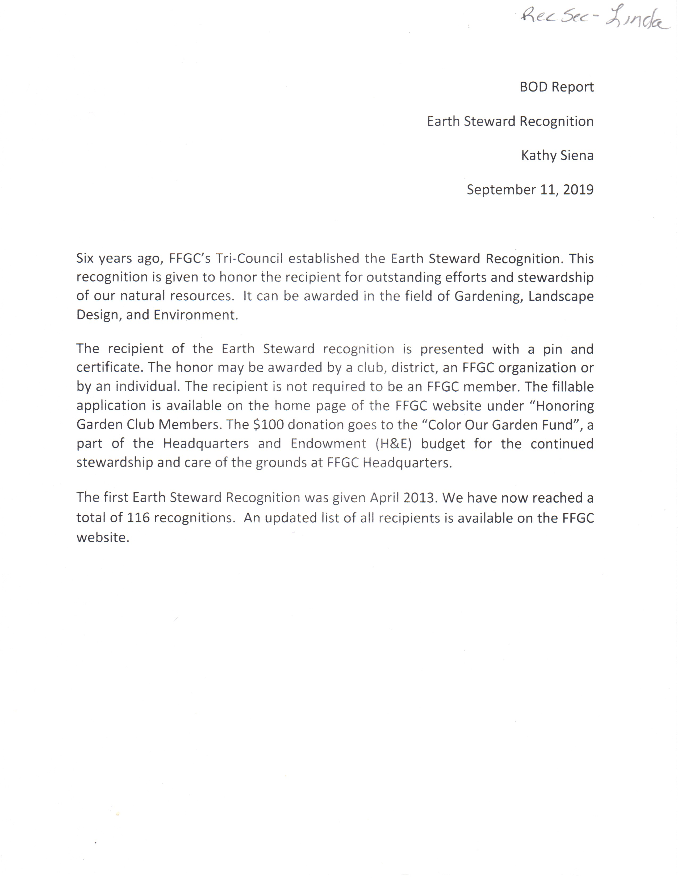

Environmental Consultants Council

Environmental Consultants Council
President Jackie Host
September 10, 2019

This has been a challenging year for environmentalists all across the United States and the rest of the world too. It makes the work that you do and who you are more important than ever. As an environmental consultant you are more informed than most people about environmental issue. By being here today you have shown a dedication to protecting the environment and staying up to date on environmental concerns.

This year we have learned that the effects of climate change on Florida will be catastrophic to the coastal areas over the next decade and cost Floridians millions of dollars to just try and handle the rise of the water. Most recently, the burning of the Amazon Rain Forest may prove to be one of the worst natural disasters the world has endured in modern times. These trees provide one out of every 5 breaths we take. Almost every living thing on this planet needs these trees to survive.

There are so many water problems we don't even have enough time to discuss all of them at this meeting. Basically, because of the explosive increase of the population in Florida, our water is literally being used up and polluted. Big businesses are water banking and being allowed by our government to get huge permits for withdrawals. They are also being allowed to put more toxic chemicals into the ocean, our rivers, lakes and springs. We know that you cannot have water problems without having air and land problems because everything is connected.

Education is the key to helping Floridians learn what they need to do to help preserve our natural resources. As Environmental Consultants you have an opportunity and qualifications to do this. You can hold meetings about conservation at your Garden Clubs and your Communities.

We need more Environmental Schools so that we can have more trained leaders to get the word out about what it's going to take to save Florida for future generations. Please consider doing this. Call me and/or Nancy Richards and we will be glad to help you.

Summary: Florida's natural resources are being diminished by pollution and overuse. Environmental Consultants are qualified to put on educational programs in their own garden clubs and communities. Jackie Host,
ECC President

FFGC Calendar Finance Report

FFGC CALENDAR REPORT
Finance & Distribution Chairman
Lori Richie
September 1, 2019

Picked up at convention 785
Mailed (Sold in Florida) 312
(Sold out of state) 40
Sold at Headquarters 13
Quaintly sold to date 1150
Complementary 70
Calendars in inventory 780

CREDITS
Sales ` 9200.00
Sales Tax 558.55
Shipping 245.80

Total credits for 2020 calendars 10004.35

EXPENSES
Sales Tax 558.55
Shipping expense 144.11
Stamps 55.00
Posters and Misc Jill expenses 45.00
Printing order forms 24.08
Printing Calendars 8884.00
Photographer 2500.00
Copy Rights Fee 55.00

Production and mailing expenses for 2020 calendars 11707.19
Total Debits 12265.74

FFGC Calendar Report

FFGC CALENDAR REPORT
Finance & Distribution Chairman
Lori Richie
September 1, 2019
Summary
The total number of calendars sold is 1150. Mailed and sold in Florida 312, sold out of state is 40. Sold at Headquarters is 13, complementary calendars 70. Calendars in inventory is 780.
Total income received is 10,004.35. Total expenses are 12,265.74. There is a negative balance of 2,261.39.
All figurers listed are cumulative figurers of all the Floral Arrangement Calendars 2020. All expenses for production of the calendars are listed in this report.
Lori Richie

FFGC Scholarship and Endowment Report

Scholarship and Endowment Committee
Board report Sept 11, 2019
Helen Purvis, Chairman
Six applications were received and reviewed by this committee. Five scholarships were awarded and the committee was sad to tell one deserving applicant that since he had transferred to a school out of Florida, he was no longer eligible to receive an FFGC scholarship.
$3000 scholarships to the following:
AUBREY LANIER-Freshman at Florida Gulf Coast University hoping to pursue dual degree in civil and environmental engineering. Wants to apply unique and innovative solutions to infrastructure and environmental issues.
Camper, leader-in-training and counselor at Camp Wekiva. Attended SEEK for 2 years. Member of Lake Placid High School FFA/Ornamental Horticulture. Recommended by Lake Placid Garden Club. Awarded $3000.
SYDNEY STEPHENS -Freshman At University of Florida. Pursuing a degree in landscape architecture. Would like to develop greenspaces in cities where land could be repurposed as a public area benefiting neighborhoods, such as community gardens to combat food deserts and wildlife waystations to reduce habitat fragmentation. Recommended by Garden Club of Fleming Island, Awarded $3000
BENTLEY MADDOX-Freshman at Florida State University, pursuing a degree in Biology with a minor in Chemistry. Attended Wekiva Youth Camp for 4 years and attended SEEK for 3 years. Member of high school garden club that promoted recycling. Recommended by Tallahassee Garden Club. Awarded $3000.
$2000 scholarships to the following:
SHEA STROUD-Sophomore at Santa Fe College majoring in Agriculture Operating Management. Was awarded FFGC Scholarship 2018-19. His teacher says he has a passion for agriculture and educates the class on the issues farmers face daily. Plans to enlist in Marines upon graduation and after serving wants to sell agriculture equipment and save up to buy a ranch. Recommended by Tallahassee Garden Club. Awarded $2000
MADELYN GODWIN-Junior at University of Florida. Finished two years at Pensacola State College. Pursuing a degree in Natural Resource Conservation with a minor in soils. Awarded Leadership Award for PSC Milton Campus. Member of livestock board for Santa Rosa County Fair. Mentors students for FFA competitions. Recommended by Sweet Bay Garden Club, Pensacola Federation of Garden Clubs. Awarded $2000.
These monies will be divided into two semesters and the students must maintain a 3.0 GPA to receive the second half in the spring.

The thank you notes from these students were so heart warming that I wanted to share them with you so there is a backboard in the lobby with their pictures and thank-yous. It is my privilege to serve on this committee with Jana Walling, Susan Hillson, Carole Martin and Lynda Perry . Many of these students had attended Wekiva and Seek, so chairman, you’re doing a good job of informing them of this opportunity. I know this seems a long way away, but if you know deserving students, the applications for Deep South and National Garden Club scholarships are February 1.
Also, I would like to acknowledge receipt of donations from the Garden Club of Deland, Pompano Beach Garden Club,and Ribault Garden Club. A special recognition and certificate will be presented to Boynton Beach Garden Club at their district meeting by President Latina for their contribution of $1000.

Mr. President, I have a motion.
SUMMARY: Ratify scholarship awards in the amount of $1500 for fall 2019 semester to: Aubrey Lanier, Bentley Maddox and Sydney Stephens; and $1000 to Madelyn Godwin and Shea Stroud .

FFGC, NGC, DS Life Memberships Report

FFGC, NGC, DS LIFE MEMBERSHIP
SANDRA MESSER, CHAIRMAN
SEPTEMBER 11-12, 2019

This Chairman will continue to process the Life Memberships awarded to deserving
Members as they are received. This information will be passed on to Headquarters so that
the members profile can be updated. Will try to encourage members to fill out the forms
completely, correctly and legibly. Will try to encourage more NGC and Deep South Life
Memberships be awarded without taking away from other FFGC honors that could be
awarded. Will continue to answer questions as they are sent to this chairman.

A statement that this chairman will fulfill the duties of this committee to the best
of her abilities.

Finance Committee Report
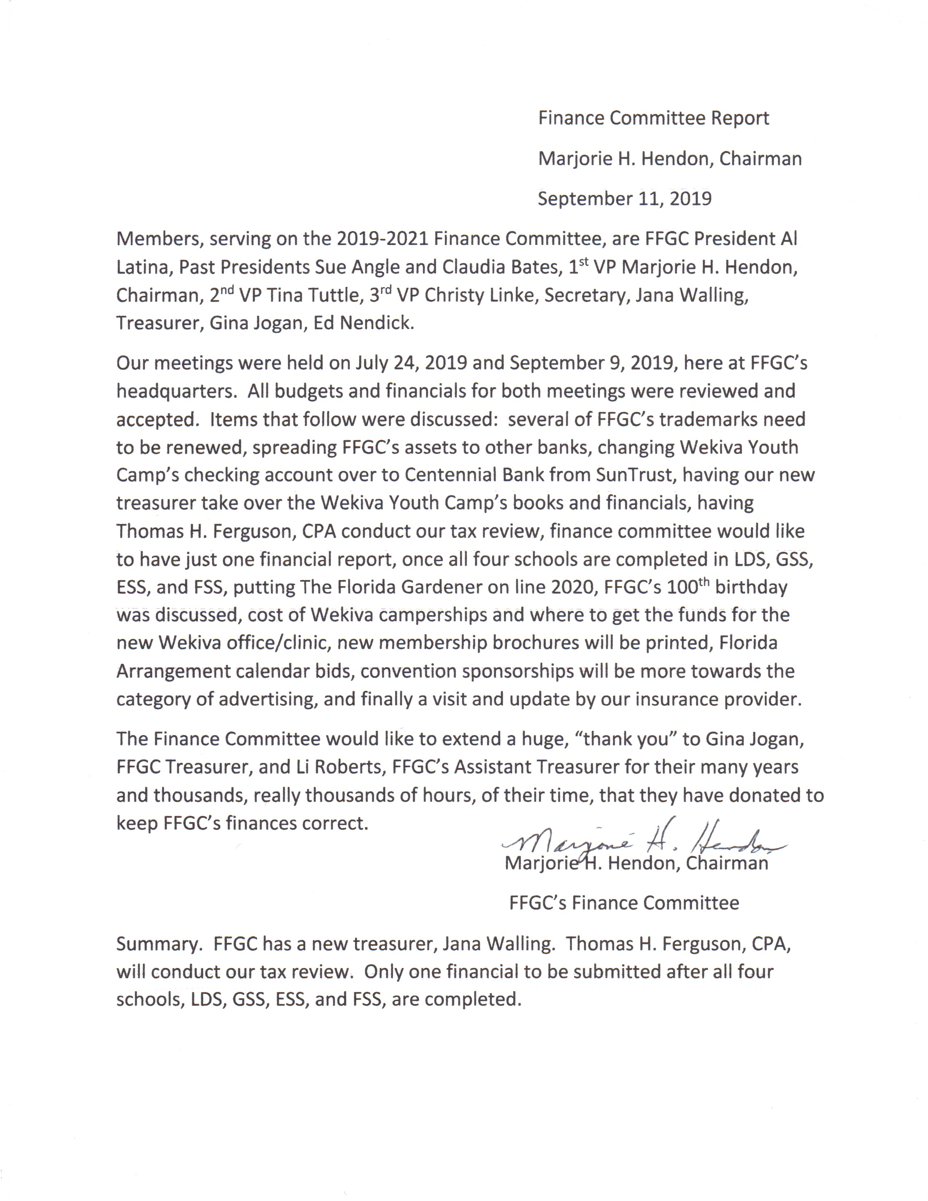

Florida Flower Show Judges Report

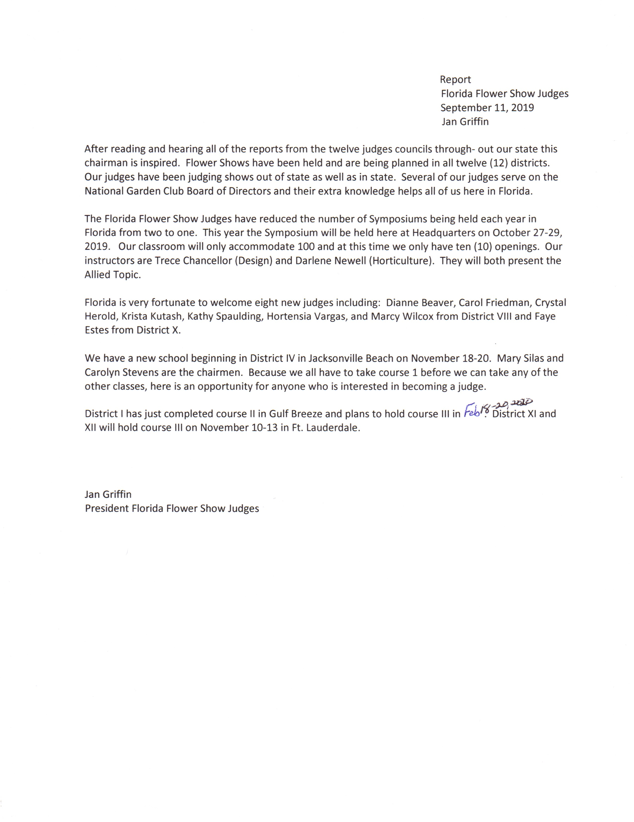

Gardening Consultant’s Council Report

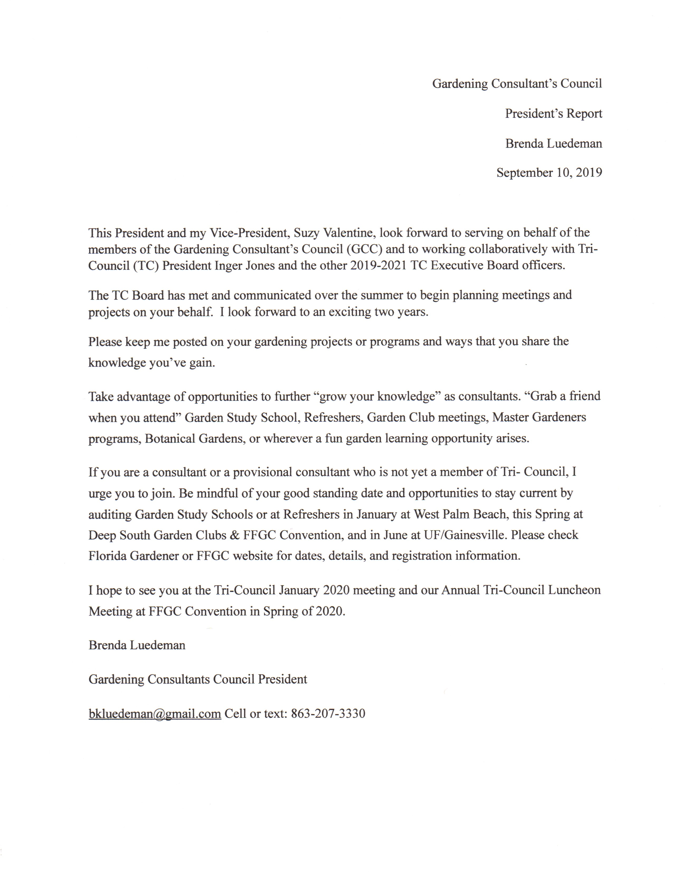

Girl Scout Liaison Report

FFGC REPORT
GIRL SCOUT LIAISON
SEPTEMBER 11, 12 2019
This chair has been rewarded by working with delightful groups of young women who are enthusiastic, energetic and awe inspiring! These Girl Scouts, juniors and brownies are a treasure that bring such joy and energy to the groups of Garden Club women who help to educate them in ways of horticulture, floral design and conservation. It is a benefit and a boon to the girl scouts to also receive an FFGC patch that they can proudly display on their uniforms which symbolizes the work they have done with our garden clubs
Most of the troops have developed plans for the year but have asked for and received a series of programs for meetings that our Garden Club members will lead the troop into earning a Florida Wildflower patch. Because of a grant we can provide the patches free of charge to any group of scouts that requests them. We also have a wealth of information to start a troop off with lesson plans and ideas from Brownies to older girls.
Our purpose as Scout Liaison is to educate the girls with facts about the benefit of wildflowers, especially how important they are to pollinators. Not just facts but using their creativity and hands on approach do these girls get the true meaning of how important Wildflowers are to the environment. By creating an awareness of the goals and philosophies of National Garden Club we can share more knowledge and information that the girls can take back to their peers and community. Another result of our involvement with the troops is that the leaders get enthusiastic and want to pursue more involvement in Garden Club, thereby we gain more interested new members.
The five lessons that we provide to the leaders help to develop a program that can be used any time of the year. By allowing the girls to learn about the area in which they live, what grows best where, what types of wildflowers will attract butterflies, what other pollinators need wildflowers helps to keep the requirements of the Wildflower patch in mind. This learning style allows for a progressive approach that brings them to wildflower planting on their own, whether it is in a large area that they have planted, or a small garden or just little pots of seeds they take home and nurture. Florida has such diverse micro-climates and what grows in one area will not produce in others, and the reverse. So, the girls from all over the state get to see the balance of nature and what works best for them.
Wildflower lessons can happen in whatever area of the state the girls are from because the lesson plans are adaptable to different climates, landscapes, and varieties of wildflowers. The various styles and ways to implement these lessons make the program generic enough that it has been used across the country in states like Massachusetts, Michigan, California and Texas. We have shared the FFGC Patch with all these states.
Summary: Girl Scouting has been proven to be a valuable tool for girls to expand their knowledge base, learn to be leaders and find accomplishment in working successfully with others. The Wildflower Patch requirements allow for Girl Scouts, Leaders and Garden Club members to explore the world of nature and use it grow within themselves and for the environment. Barbara Rao FFGC Scout Liaison

Grants Report

REPORT
GRANTS
Carolyn Schaag
September 11, 2019

Summer months are usually slow as few requests are received from the various FFGC chairmen. One application was made to a major airline for donation of airline tickets
for the Convention raffle. This request was denied, possibly due to impact to airlines
because of design problems.

This chairman is still trying to establish other ways to assist FFGC in receiving funds and goods.

Carolyn Schaag
Grants Chairman

SUMMARY: The only application this summer for airline tickets was denied by
the airline.

