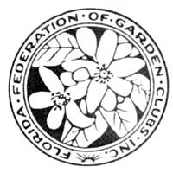 Precious Metal Certificate
Fill out Form and forward it to the appropriate District Director for submitting to FFGC Headquarters with a request for a Certificate
FFGC recognizes Club Loyalty with a Precious Metal Certificate which recognizes the number of years the Club has been FEDERATED from the current year. The Club should contact their District Director and provide a copy of the Precious Metal Form with a request to obtain the Certificate which will be presented at a District Meeting. The District Director may present the Certificate, or if the meeting coincides with the FFGC Officers in attendance, the FFGC President may be asked to present the Certificate as an alternative option.
Levels of Recognition of years Federated (Circle the years of recognition)
95 Years: Blue Diamond 90 Years: Pink Diamond 85 Years: Yellow Diamond
80 Years: Double Diamond 75 Years: Diamond 70 Years: Emerald
60 Years: Ruby 50 Years: Platinum 40 Years: Gold
30 Years: Silver
Club __________________________________________________________________________

Years Federated from Current Year ________________________________________________

District _______ Director ____________________________________________________

When Needed _________________________________________________________________

By Mail and send to Whom ______________________________________________________

_____________________________________________________________________________

Will Pick up by Whom __________________________________________________________
Precious Metals Rev. 2020

